April's Green Tea: 421 West Walnut Street Gardena Ca, 90248
Tea was first harvested in China over 2,500 years ago. Shortly thereafter, green tea was introduced in Korea. Tea had a great impact on Korea's culture, religion, and was used in ceremonies. Korea has a long history of producing excellent tea. Korea's green tea are rarely grown, therefore it is very precious and delicate.
In the 7th century, (the Shilla Dynassty), tea was initially mentioned. Two hundred years later, tea seeds from China were planted at the foot of Mt. Ji-Ri, near the village of Ha-dong and Sa-Chun, where our April's Green Teas are cultivated.
(For more information aobut Korean Green Tea, please link to http://en.wikipedia.org/wiki/Korean_tea)
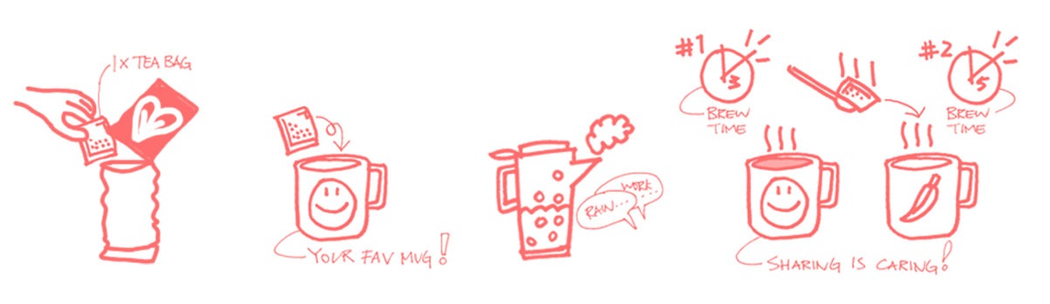

Why April's Green Tea?
In order to understand why April's Green Tea is special, it would be beneficial to know about the harvesting seaons of green tea leaves in Korea.
On average, green tea is usually harvested four times a year in Korea(Ujeon,Sejak, Jung-Jak, and Dae-Jak). Ujeon is the first season to be harvested because it provides a more milder and fresher taste. It consists of leaves picked in the first month between the 10th and 20th day of the fourth lunar month. The youngest leaves that are harvested in the first month deliver delicate flavor, fragrance, and pleasant after-taste.
In the season of Ujeon, the tea leaves mostly contain Amino Acid, Vitamin C, Caffeine, and Antioxidant. April's Green Tea is made in the season of Ujeon because it is 100% of natural premium quality. In addition, there is a limit on how much that can be produced from the Mt. Ji Ri region(South Korea), because of the fact that there are less than 1% of green tea leaves in the world that are cultivated. April's Green Tea is available in four different flavors: Original, Apple, Blackberry, and Honey Lemon. Each flavor has its own strong unique aroma that allows a person to feel more refreshed and relaxed.
Amino Acid | Antioxidant
Cell Growth | Reduced risk of cholesterol oxidation
Muscle Building Recovery | Strong Immunity and residence to virus
Storing Protein | Reduced High Blood Pressure
Help to boost and support immune system and digestion | Help to weight Loss
April's Green Tea is made with Ujeon and it is 100% natural premium quality of green tea product. In addition, it is limited production from Mt. Ji Ri Region of South Korea where less than 1% of green teas in the world are cultivated.
April's Green Tea comes with four different flavors (Original, Apple, Blackberry and Honey Lemon). Each flavor has a unique strong aroma and it allows you feel more refreshing and relaxing.

What people say about April's Green Tea
Original:
"The Original flavor is very soothing and has a refreshing mild taste."
Apple:
"Crisp and refreshing taste. It doesn't taste like any artificial flavor has been added."
Honey Lemon:
"Doesn't have a plant-like taste, instead it has a smooth and mellow taste."
Blackberry:
"Love it due to its strong blackberry overtones and the beautiful purple color that emerged."

Geographical Feature
What gives Korean tea our distinctive taste and aroma has more to do about weather and geographical feature.
Moutain Ji Ri in the region of Ha Dong, is located along the Sum Jin Jang(River), the opposite side of Jeon Ra Nam Do. The climate in that region is mild and while the average temperature is maintaining 14.3 Celsius. This is affected by the season due to the wind coming from the So Back Mountain Range. The high quality of the green tea and excellent taste is provided by the contribution from the weather.

HVACR Equipment PM Contract Specifications

Roof top Packaged Unit specifications
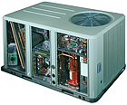

5 Trane 5 Tons 17 Plus Packaged Rooftop Units
Unit # | Model # | Unit Type | Serial # | BTU Cool | BTU Heat | High CFM | Filter | Power
1 | YHC060E4RHA | Gas/Electric | 14356CVK1G | 60 K | 130 K (MBH) | 2000 | (2)16x25x2 | 460/3ph
2 | YHC048E4RHA | Gas/Electric | 14568JEN1G | 60 K | 130 K (MBH) | 2000 | (2)16x25x2 | 460/3ph
3 | YHC060E4RHA | Gas/Electric | 14167TPK1G | 60 K | 130 K (MBH) | 2000 | (2)16x25x2 | 460/3ph
4 | YHC060E4RHA | Gas/Electric | 14498GPA1G | 60 K | 130 K (MBH) | 2000 | (2)16x25x2 | 460/3ph
5 | YHC060E4RHA | Gas/Electric | 14468NQT1G | 60 K | 130 K (MBH) | 2000 | (2)16x25x2 | 460/3ph

