Unit Information

➮ EQUIPMENT DATA
OUTDOOR UNIT
Model #: ______________________________ Serial #:_____________________Date Installed:_ _______________
EVAPORATOR
Model #: ______________________________ Serial #:_____________________ Date Installed: _______________

➮Refrigeration System Data

Pressures ➮

Compressor Discharge
Compressor Suction
Liquid Line
Saturated Condenser
Saturated Evaporator

Temperatures ➮

Discharge Temperature
Suction Temperature
Liquid Line Temperature
Saturated Condenser Temperature
Saturated Evaporator Temperature

➮Air Side System Data

Return Air Dry Bulb Temperature
Return Air Wet Bulb Temperature
Supply Air Dry Bulb Temperature
Supply Air Wet Bulb Temperature
Supply Air Enthalpy
Return Air Enthalpy
Unit Air CFM
Unit Calculated BTU’s
OSA Temperature

Electrical Data ➮

Compressor Average Current
Supply Fan Average Current
Condenser Fan Average Current
Unit Average Running Voltage
Unit Average Running Current
Unit Average Power Factor
Unit Average Watts
Unit Calculated EER
Unit Calculated COP
Rated Unit Voltage
Rated Unit FLA
Rated EER

➮Formulas System Data
BTU’s | BTU/HR=4.5 x CFM x DELT (BTU/LB)
Tons | Capacity/12,000
CFM | CFM= AREA x VELOCITY
Area Rectangular Duct | A=(L(inches) x W(inches))/144
Area Round Duct | (PIE x DI. SQ.) / (4x144)
1 Phase Watts | Watts = PF × amp × volt
3 Phase Watts | Watts = V avg. x A avg x p.f. x 1.732
EER | EER= output cooling energy in BTU/Input electrical energy in Wh
COP | COP=Power output/Power input
BTU to Watts | 1 BTU = 0.293071 Watts
Capacity
Unit BTU: ____________________
Unit Watts: __________________
Unit EER: ____________________
Unit COP: ____________________

Out Side Air
DB:____WB:____
Mixed Air
DB:_____ WB:____

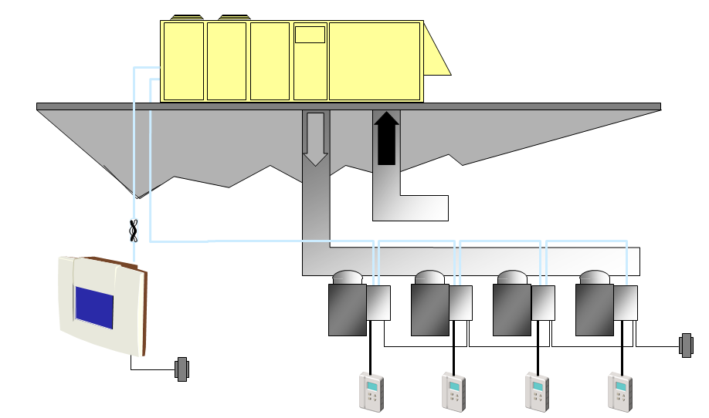
Return Air
DB:_________ WB____________
W

Supply CFM
CFM:________

Supply Air
DB:____WB:____
Name | Signiture | Class | Date

